# Title Page

2307-BSE

Cross Platform Dev – Prototype

CS203.2

Alex Legner (270168960)

# Document Outline

## Table of Contents

Title Page 1

Document Outline 2

Table of Contents 2

Table of Figures 2

Table of Tables 2

Report 4

Weekly Scrum Meeting/Minutes 4

Changes To Initial Plan 6

Collaboration 7

Roles/Responsibilities 7

Self-Reflection 9

## Table of Figures

Figure 1: Scrum Week 1 4

Figure 2: Scrum Week 2 4

Figure 3: Scrum Week 3 4

Figure 4: Scrum Week 4 4

Figure 5: Scrum Week 5 4

Figure 6: Scrum Week 6 4

Figure 7: Scrum Week 7 5

Figure 8: Scrum Week 8 5

Figure 9: GitHub Repo - Contributors 8

## Table of Tables

**No table of tables.**

Intentionally Blank

# Report

## Weekly Scrum Meeting/Minutes

Figure : Scrum Week 1

Figure : Scrum Week 2

Figure : Scrum Week 3

Figure : Scrum Week 4

Figure : Scrum Week 5

Figure : Scrum Week 6

Figure : Scrum Week 7

Figure : Scrum Week 8

## Changes To Initial Plan

We did have some changes due to various limitations which will be explained below:

* The prototype will not function on the WEB page like we had originally intended it to be for. This was due to the networking limitations of our backend code. We could have found a framework to allow packet transfer through the web however, unfortunately we ran out of time. The prototype is fully functional as an .exe file. This could theoretically be made to work on the web but would require more time in the future if we choose to expand upon the prototype we have completed.
* Some power ups were not implemented due to time constraints. We did not have enough time to implement all the powerups. This is because they would require significant coding time and testing time which we do not have. We have added a temporarily “this is not implemented yet” pop up into the game to prevent this as being a “bug”.
* There have been some changes to the game play itself, this was due to both time constraints and the fact the team agreed while developing/testing that the core mechanics needed to be changed to ensure we had a fun and playable game.

## Collaboration

### Roles/Responsibilities

Each team member was put in roles that they felt they were strong in. This made sure everyone was working on something they were confident in doing which made the work go a lot quicker and smoother.

Alex L:

* **Primary Backend Developer** – Is responsible for the development and maintainability of the backend related code. This may include some interfaces which allow front end code to work with back-end code.
* **Project Manager** – Is responsible for the overall project and any issues that may arise during said project.
* **Product Analyst** – Is responsible for looking into products to find strengths and weaknesses to help the development of products by learning from these strengths and weaknesses.

Alex C:

* **Scrum Master** – Is responsible for keeping everyone on task and on time. They can make meetings with the team to bring everyone together and get everyone on track again.
* **Product Analyst** – Is responsible for looking into products to find strengths and weaknesses to help the development of products by learning from these strengths and weaknesses.
* **Devil’s Advocate** – Is responsible for making decisions that the group can’t decide on together and critiquing all work within the project to make sure it is up to standard.

Will T:

* **Concept Programmer** – Is responsible for creating backend related code concepts which will be able to prove theoretical code related concepts.
* **Main Designer UX** – Is responsible for the development of the LoFi and HiFi prototypes and designs for the project.
* **Concept Testing** – Is responsible for user testing of the prototypes and concepts required within the project.

Liam K:

* **Hype Man** – Is responsible for keeping the team hyped up and on task. Keeping the motivation up during any tough times.
* **Target Audience Analyst** – Is responsible for knowing and researching the target audience for the project.
* **Concept Manager** – Is responsible for the overall concept of the project and making sure the prototype is what was expected as the overall concept.

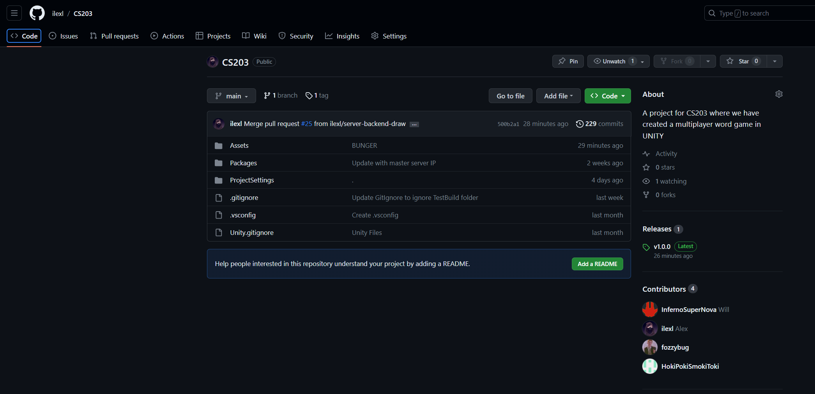

Figure : GitHub Repo - Contributors

All four of us have contributed to the development of the prototype in some way or another – specifics can be found on <https://github.com/ilexl/CS203> as there are too many, however we all worked collaboratively which resulted in us being able to produce a functional prototype by the end date.

## Self-Reflection

**Reflection on learning in terms of technology:**

From developing this prototype, I have learnt many different aspects of the technology used for this project. This includes using git for collaboration, learning a multiplayer framework for Unity, and learning how to make computers say the right things to each other. This has not only helped me gain knowledge for any future projects but also give me a deeper understanding of Unity’s code/framework to better utilise everything it has to offer.

**Reflection on the project overall:**

Overall, the project went relatively smoothly. We did have some unforeseeable issues which we did not have time to fix, however we created a MVP for a fully functional prototype. There are some parts that are not finished yet which include: single player/AI, some of the games power ups and networking through the web, but otherwise the app is fully functional including multiplayer. I thought the team was fun and nice to work with and the collaboration was seamless. Overall, to me the project was a success and we have left with a functional game.

**Reflection on what you would do differently next time:**

Next time I would allow for more time for developing the prototype. Our timeframe was fixed with no room for error which was outside our control. Next time we should consider the time frame and possibly create a smaller scope/project. If I could change one more thing it would be to have more time to research while in the development process of the prototype, this would allow for us to create small little prototypes for testing and further increasing the quality of the prototyping process to create a better prototype.